INTRODUCTION – The Parks & Recreation Department often handles cash, checks and credit cards payments that must be deposited into the city’s treasury. These collections, from a wide variety of sources and for a wide range of purposes, require the establishment of uniform deposit procedures. The following procedures will assist with maintaining the accountability for and documentation of the custody of cash when transferring and depositing these funds.
FREQUENCY OF DEPOSITS – Current day collections must be processed for deposit the same day. All deposits must be accompanied by appropriate Cash Receipt Report showing appropriate workstations at the center, check running tape, Recreation Cash Reconciliation Record envelope with tape.
POLICIES –
- If there are two people available, please count the deposit to ensure it is correct/matches. The counting must be done separately and not together. Once complete, both must sign the Cash Receipt Report signifying that they match unless the following occurs, then only one person can sign the Cash Receipt Report:
  - If there are no transactions and nothing showing on the report. (Remember: The report as a deposit must still be sent to the Finance cashier).
  - If there is only credit card transactions showing on the report.
- Counting of the deposit will be away from public view.
- If the deposit is off more than $5; a full-time person must recount and sign off that they did their due diligence and the monies are still off.
  - If this full-time person is not a Recreation Area Manager (RAM) then an email must be sent to the RAM. The RAM must then send an email to Finance cashier (Michele Frey) and copy the following people: Julie Lopez, Colette Wengenroth, Sue Spickard and Bonnie Elliott.
CLOSING PROCEDURES

To prepare for the deposit, take a Recreation Cash Reconciliation Record envelope and either stamp it with your center’s address or hand write your center’s name on the front. This will be used to hold all the cash, checks and deposit reports as you verify them. This envelope will then go into a locking moneybag once you are finished with the steps below.

- Cash Receipt Report

A Cash Receipt Report needs to be run at the end of every day, to accompany your deposit to the Finance Department. This report should be run at 5:00 pm. or approximately ½ hour before closing.

- Select the Report Icon in top header
- Select Cash Receipt in the Daily Close Reports box

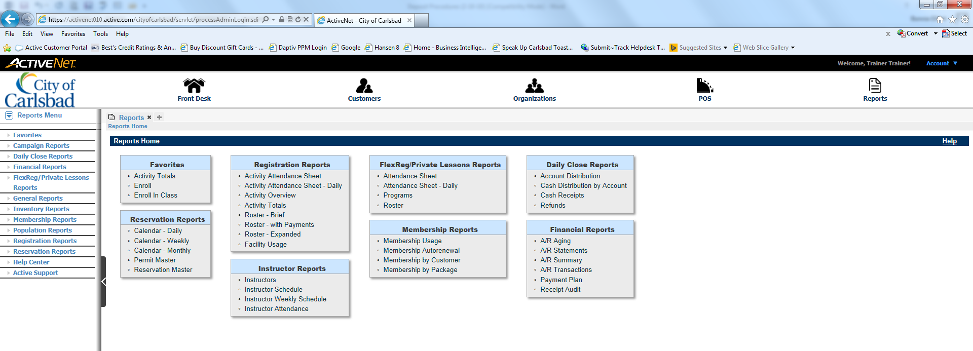
- Fill in the Receipt Date/Time information. Note: Time should always be 12:00 a.m. to 11:59 p.m.
- Make sure to remove Parks & Recreation and Internet Site – City of Carlsbad in the Transaction Site box. (To do this highlight the names and click on the Remove button.)
- Make sure to add all the workstations from your center that reports are to be pulled from by clicking on Workstations. Another box with all workstations listed will pop up. Select the button beside the workstation that you want to populate in the Workstations reporting box and go to the bottom of the box and select Add All Selected and then Done. This will place those workstations in the Workstations reporting box.
- Click Summary Report

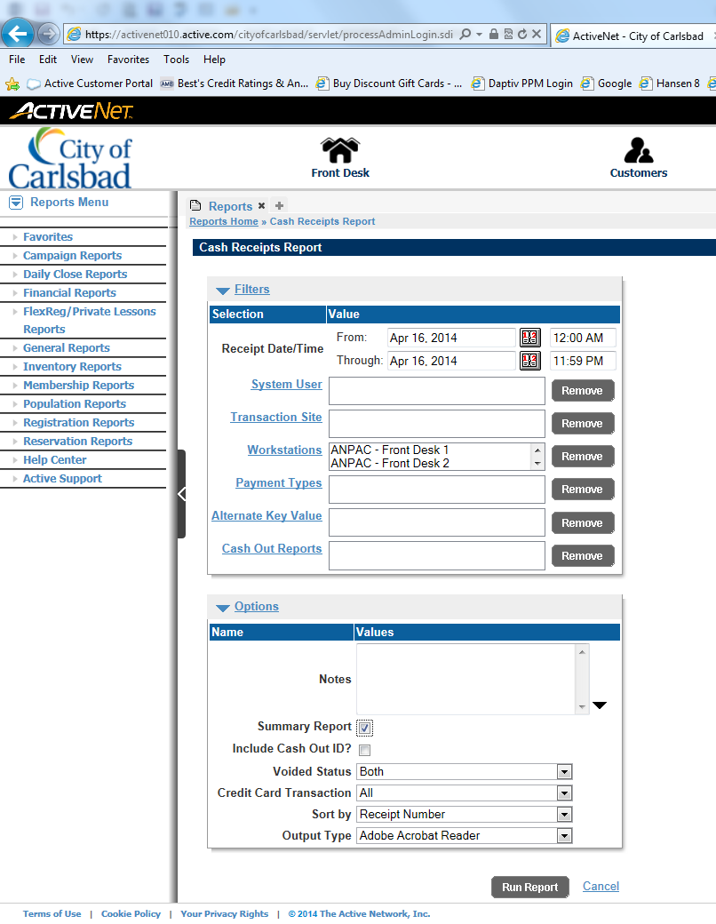
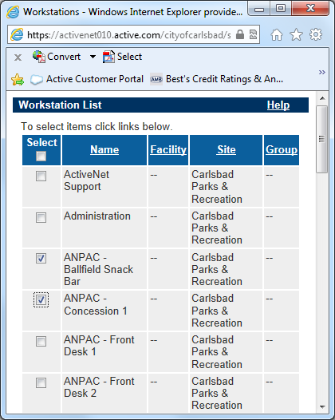

Print two (2) reports. One is to be sent with your deposit and one should be kept as a record. Put to the side for now.

NOTE: A separate Cash Receipt Report must be done each date, no matter if there is cash, checks, or credit or not.

Count out your starting float and put in to your holding bag to be locked up in your safe.

Note: Your float is: $______________________

- Cash:

Count the remaining cash that was taken in that day and fill out the Recreation Cash Reconciliation Record envelope. Make sure to place the number of bills for each type of bill and totals in the ‘CURRENCY’ column. Add your totals and write it in the ‘SUBTOTAL’ line for the currency.

Make sure to place the number of coins for each type of coin and totals in the ‘COINS’ column. Add your totals for bills and write it in the ‘SUBTOTAL’ line for coins. Add both the currency and coin subtotals and write the total in the “CASH:” line in the “TOTALS” column. Check your cash total against the cash net total on that day’s Cash Receipt report. If it balances, paper clip the bills together. Place the loose coins in a coin envelope. Place all the cash in the Recreation Cash Reconciliation Record envelope. If balances do not match, go to “Troubleshooting” section of this report.

- Checks:

Take out your checks that were taken in for the day and make sure all the checks are stamped on the back with your “Pay to the Order Of” stamp. Look at the front and make sure all of them are made out to “The City of Carlsbad”. Add all the checks together using an adding machine with a tape. Check your check total against the check net total on that day’s Cash Receipt report. If they balance, clip the checks together with the calculator tape on top and place them in the Recreation Cash Reconciliation Record envelope with the cash. Write the total of the checks in the “CHECKS:” line of the “TOTALS” column on the Recreation Cash Reconciliation Record envelope. If balances do not match, go to “Troubleshooting” section of this report.

- Credit Cards:

Write the total for all four credit card types (Visa, MasterCard, Discover and American Express) in the “CREDIT CARDS:” line of the “TOTALS” column on the Recreation Cash Reconciliation Record envelope.

- Grand Total:

Run a tape of all the totals (cash, checks, and credit cards) and write the total in the “TOTAL RECEIVED:” line. Double check that the total on the Recreation Cash Reconciliation Record envelope matches the total on the Cash Receipt report. If they balance, staple the tape to the back of the Recreation Cash Reconciliation Record envelope. If balances do not match, go to “Troubleshooting” section of this report.

- Over/Short:

If after doing your due diligence in trying to find where your monies are over/short you may need to correct your Cash Receipt Report to your actual monies. To do this you will need to know how much monies you are over/short.

- Monies is showing less than what the Cash Receipt Report is showing (Cash being deposited is $100 and receipt is showing $105)

  - Go into the POS Module and click on the Refund Item button then the Over/Short button. Put the amount that the cash and report are different. (in this case it is $5) and click Okay. The Refund box will change to a red/pink color and show a negative amount.

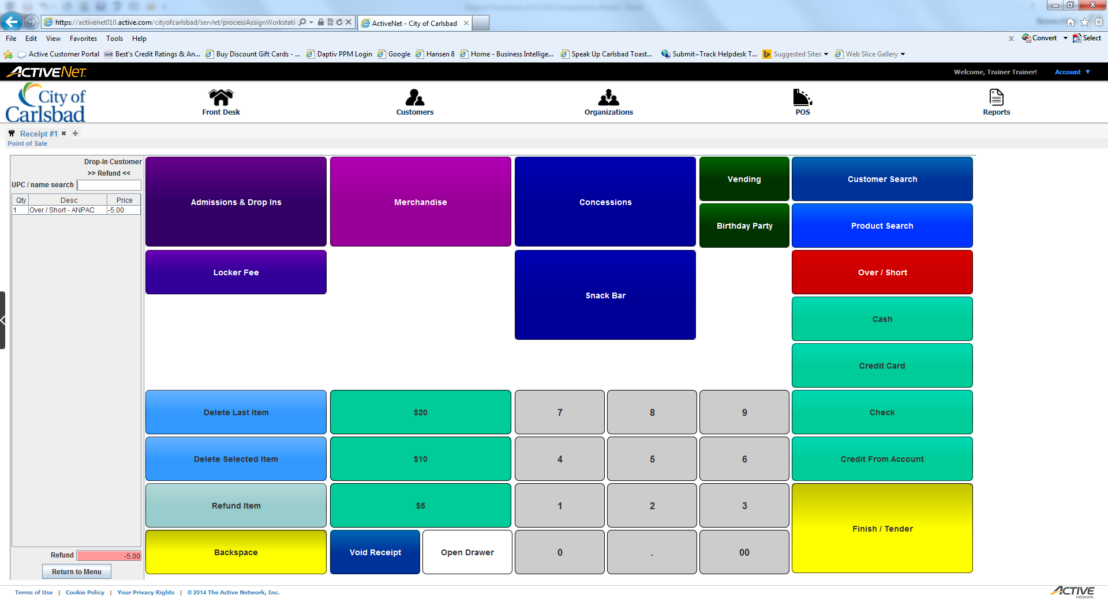

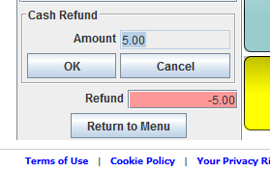

  - Next click on the Cash button and make sure the number amount is the same as the refund amount ignoring the positive/negative. Click the Ok button and the amounts will now match. (-$5.00).

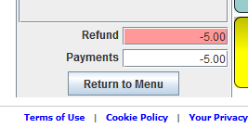
  - Click on the Finish/Tender button and a receipt will be generated. An email will automatically be sent to the CarlsbadConnect.org email address.

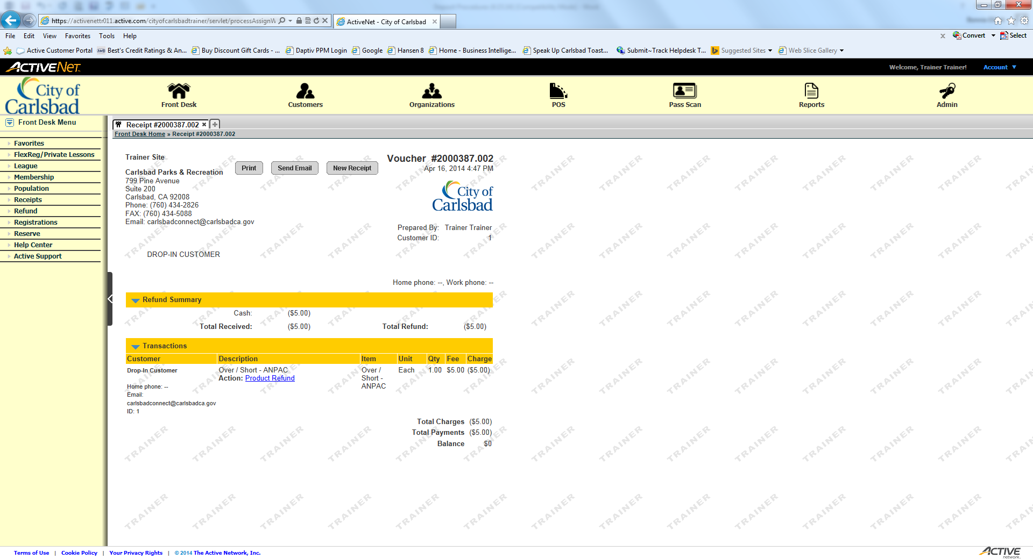

- Monies is showing more than what the Cash Receipt Report is showing (Cash being deposited is $105 and receipt is showing $100)

  - Go into the POS Module and click on the Over/Short button. Put the amount that the cash and report are different. (in this case it is $5) and click Okay. The Refund box will continue to be white and show a positive $5.

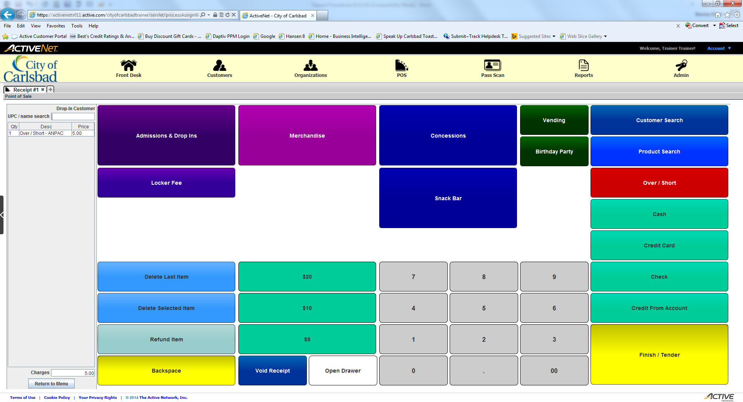

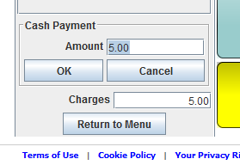
  - Next click on the Cash button and make sure the number amount is the same as the refund amount. Click the Ok button and the amounts will now match. ($5.00).

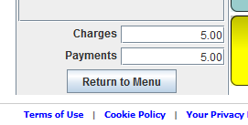
  - Click on the Finish/Tender button and a receipt will be generated. An email will automatically be sent to the CarlsbadConnect.org email address.

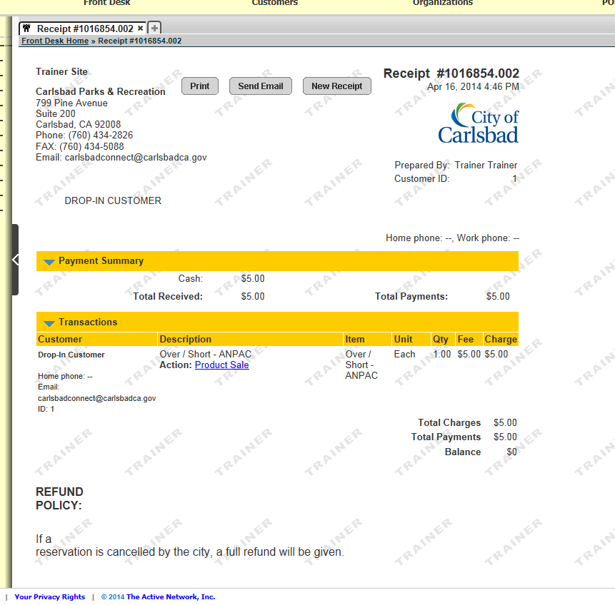

Both individuals that counted the monies must sign and date the Cash Receipt Report. Place report in the Recreation Cash Reconciliation Record envelope you made up earlier, making sure the cash, checks, and Cash Receipt Report are in the envelope. Then place the envelope in the moneybag; lock the lockable money bag and place in safe.

Place the second Cash Receipt Report in your center’s Daily Revenues Reports binder.

Note: It is important to keep a copy in case Finance says they don’t have your reports for that day; you may pull it out to verify it was sent with your deposit funds.

NOTE: All cash, checks and credit cards listed on the Cash Receipt Report should match exactly what is in your deposit, minus your ‘starting funds’. If not, you will need to put the difference in ActiveNet; POS module using the over/short button.

Note: Extra moneybags should be kept in a location that is handy for the other staff making deposits. Your bags are kept: ______________________________________________________________________________________________________________________________________________________________________________________________________________________________________________________________________________________________________

TROUBLESHOOTING

“Monies don’t match the Cash Receipt Report.”

Double check that the cash, checks, and credit cards matches the net that is being reported on the Cash Receipt Report. If there are any discrepancies, try the following:

- Recount your cash and checks again if that is the issue.
- Check to ensure you have included all workstations and/or if someone used the wrong workstation. Sometimes people have not checked their workstation before starting transactions. We’ve found that looking in the workstation ActiveNet Support you will find where transactions are.
- If that doesn’t find the problem preview a ‘detailed’ Cash Receipt Report and make comparisons individually with cash, checks, and credit cards as this is where any error usually occurs.
- If you find the difference in the inputting of the method of payment on the report:
  - Go back in and make the proper transaction.
- You will need to reprint your Cash Receipt Report again to show the correct figures. Make sure to double check everything again!
NOTE: You can only cancel/void payments on the same day they are taken. So it’s important to cancel payments entered incorrectly as soon as the mistake is noticed.

